Question 10:
Build a dictionary of five players and their scores. Print the score of each player.
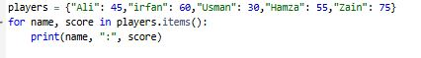
Output:
